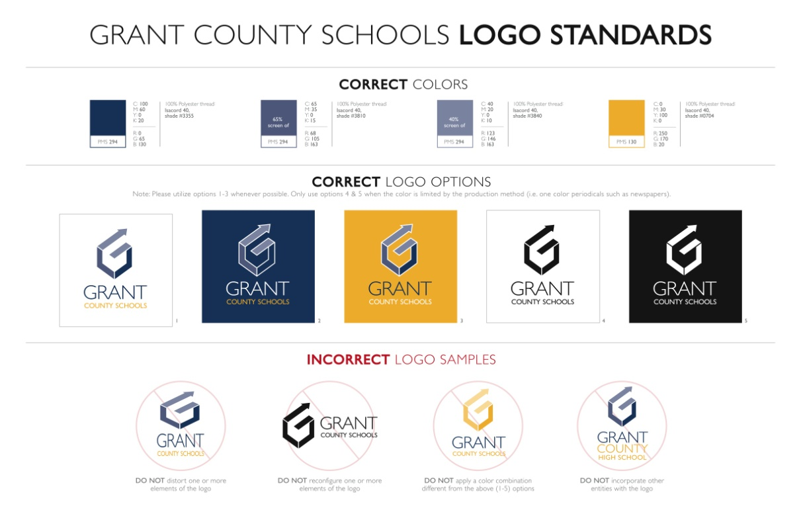

**Grant County Public Schools Request for Educational Records**

**CURRENTLY ENROLLED STUDENTS MUST CONTACT THEIR SCHOOL OF RECORD**

**Failure to complete the following information will cause a delay in processing of your request.**

FULL Name at the time enrolled in school

Last: _________________________ First: _____________________________ Middle: _______________________

Married Name: DOB: SSN:

School last attended: Grant County High Eagle Creek Academy Grant County Middle



CHECK ONE of the following: Year of graduation ______________ Last Year attended ________________

Records you are requesting Transcript Other: __________________________________________

Telephone number where you can be reached _____________________________________

**Chose the format in which should this request be returned; pick up or mailed are official; email and fax are not:**

**Pick Up** (By whom if not the person requesting the records)

**Mailing: Name: _______________________________________________________________________________**

**Street: _____________________________________________ Number____________ Apt Number**

**City/ State: ___________________________________________________________ Zip Code:____**

**Fax Number: ________________________________________ Name: ____________________________________**

**E-mail Address: _____________________________________ Name:______________________________________**

**Verification of Drivers License or Picture ID**

I certify that I am at least 18 years of age or a graduate making the above request concerning **my own** school

records, or if a minor I am the parent/ legal guardian having custody of the student named above. **Due to Federal regulations a parent can only request this information if individual is under the age of 18 years.**

_________________________________________________________ Date:

Student/Graduate signature

Or if a minor parent/legal guardian signature

**Return to linda.justice@grant.kyschools.us or fax to 859-824-3508 attn: Linda Justice**